# 12/10/2018

# Assessment Part 3 Timothy Howard - 14405064

# Emerging Techniques

To account for the demographics of people with disabilities that hinder them using or seeing a graphical interfaces I’ve applied a few emerging techniques to aid the user in using and navigating this interface with ease.

* Drop Shadows
* Path Orientated Flow
* Vibrant Saturated Colors
* Traffic Light Logic

Drop Shadows   
Throughout this website I have followed a layered approach by adding drop shadows to key elements so the user can clearly differentiate the backgrounds to the usable interface.

Path Orientated Flow  
In designing this interface I’ve laid out content throughout this website in a way that it follows a singular path so it’s easy to follow with the eye.  
  
Vibrant Saturated Color Schemes  
Using a color palate of vibrant saturated colors I’ve aimed to make the backgrounds and the interface as separate and clear as possible to the user spends less time determining what part of the website is usable.

Traffic Light Logic  
I’ve applied Traffic Light logic to any and all clickable buttons on this interface so that users that are unaccustomed to using technology to certain degrees can follow along a system that they can navigate clearly.

Pros & Cons of these Techniques & Future Goals  
As discussed above we can clearly see the positives from using these techniques but the cons to this is quite big, with changing any interface there comes the glaring problem of user error no matter how much we try to fix this human element.  
So having a feedback / FAQ page would be required for a future goal as the website if live and maintained would be updated so any changes would need to be explained.  
It’s also very important to never get caught up in the artistic design as I did because as flashy and nice looking the website is in the end the user only cares about what the need to get to in the content.

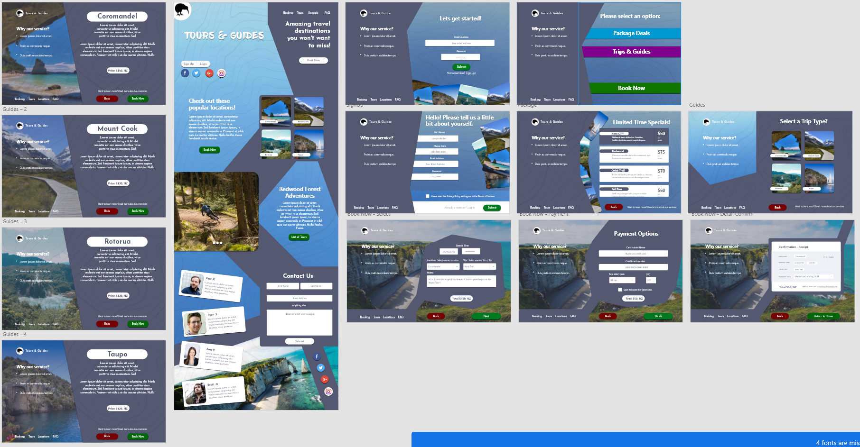

|  |
| --- |
| In these slides you are able to see the use of both drop shadows and Traffic Light Logic |

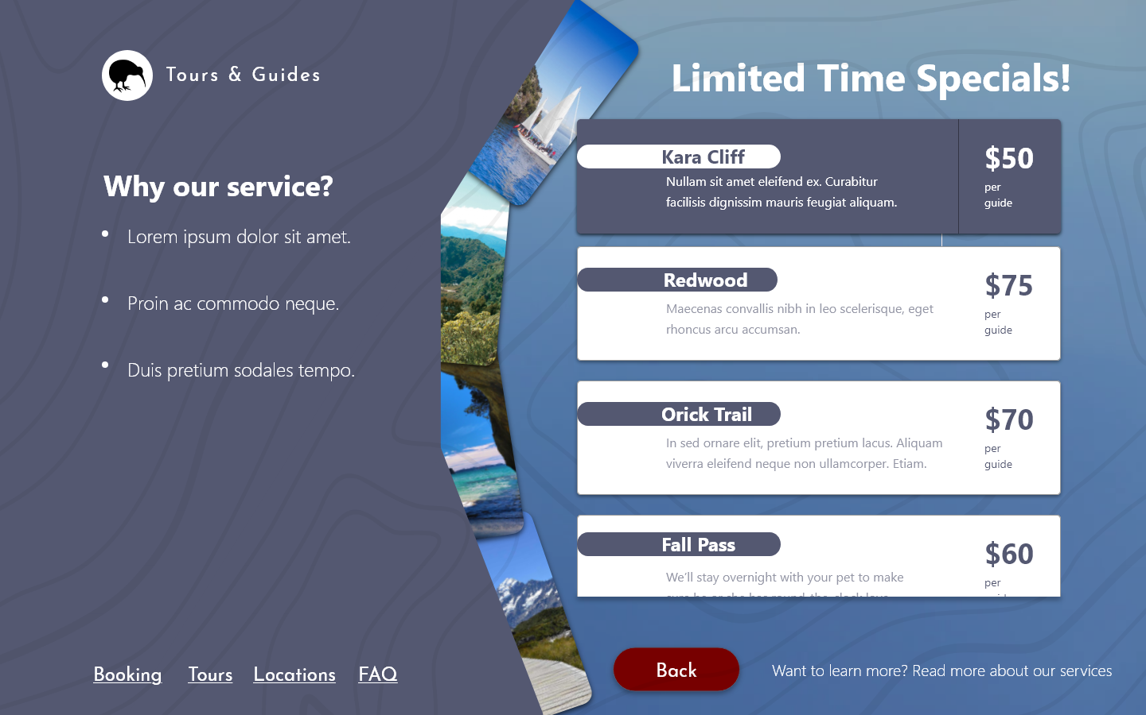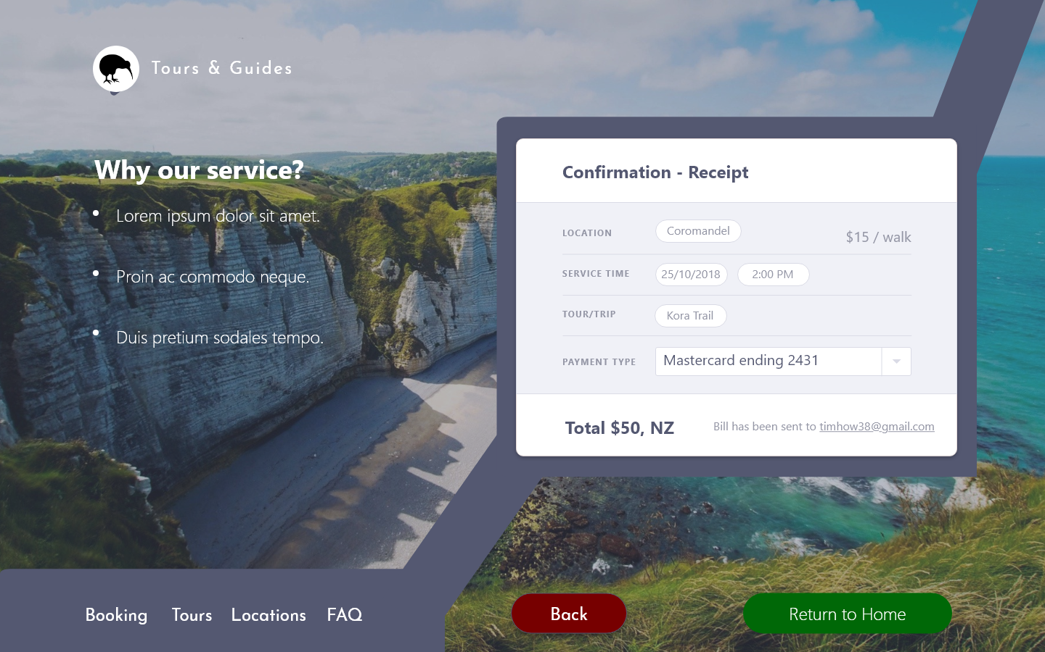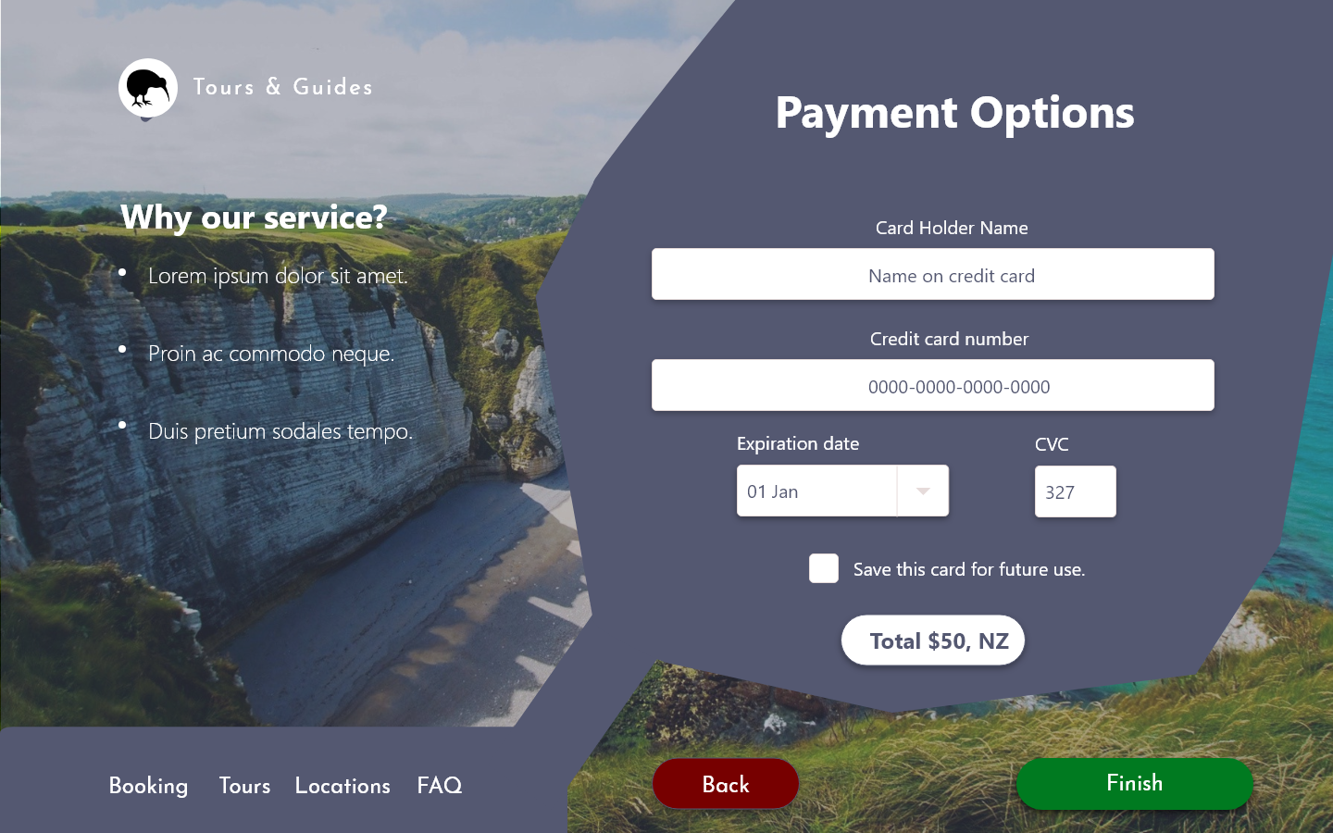



Vibrant Saturated Colors

Path Orientated Flow